Spring Project Creation

Let’s be honest, setting up a skeleton project by hand can be trying at best. No one likes to do it and you only have to do it when beginning work on a brand-new project. Thankfully spring has a tool that will generate a starter project for you with very reasonable defaults and a bit of customization that makes it easy to start on a new project.

# Spring Initializer

The tool that spring has created is the spring initializer at <https://start.spring.io/>

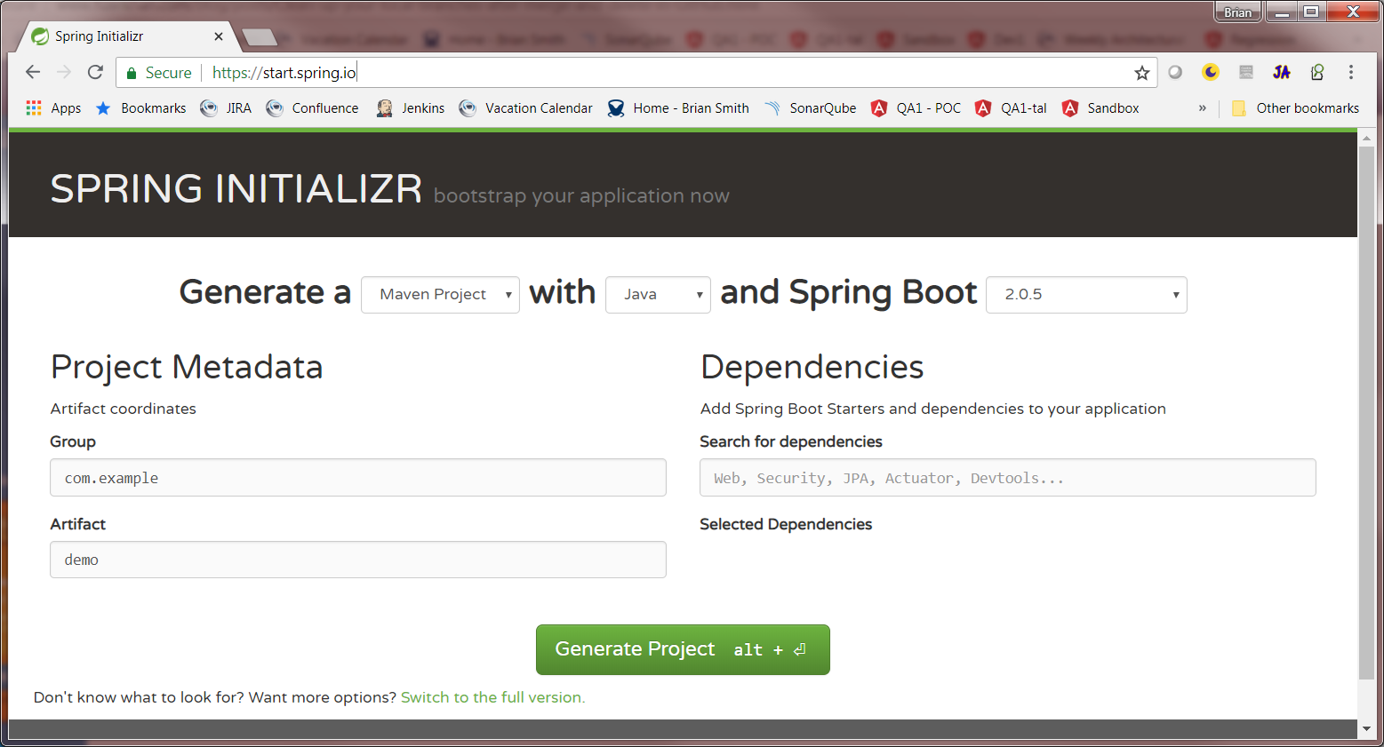

This allows you to create a project with several options

## Build System

Currently supported is either Maven or Gradle

## Language

Spring can be used by any JVM language but the initializer knows how to set up the project to use Java, Kotlin, or Groovy

## Spring Boot Version

This has a range of versions, in general the default will be the best option.

## Metadata

This allows you to define the Group and Artifact used by Maven to construct your artifacts and place them into repositories.

## Dependencies

This will be your initial set of Spring modules that you have in your project. You can always add additional ones later if you need to by adding them to either your pom.xml or your gradle.build files.

Sometimes its hard to know what dependencies to add, so I would suggest clicking the link below the Generate Project button to switch to the full version of the initializer page. This allows you to pick dependencies via check box.

## 

A good general rule of thumb is that you should check the DevTools in Core and Web in Web assuming you are creating a web application. You can scroll through and check any other modules that you know you will need for your project or just leave it at those couple.

# Getting the project

Once you are done with the setup then you can click the Generate Project button which will download the project as a zipped folder. Un zip the folder to the location you want to keep the code in and then we can import it into Eclipse.

# Importing a maven project into eclipse.

For this we will assume you have create a java maven project. For other setups the process should be fairly similar.

1. Open Eclipse with a new workspace.
2. Go to File -> Import project  
   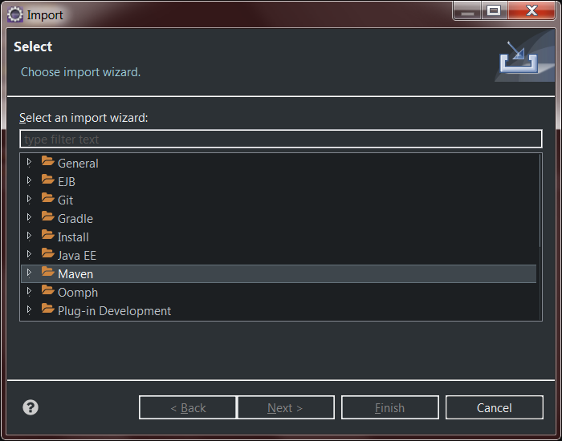
3. Scroll down and open the maven folder and select existing maven projects  
   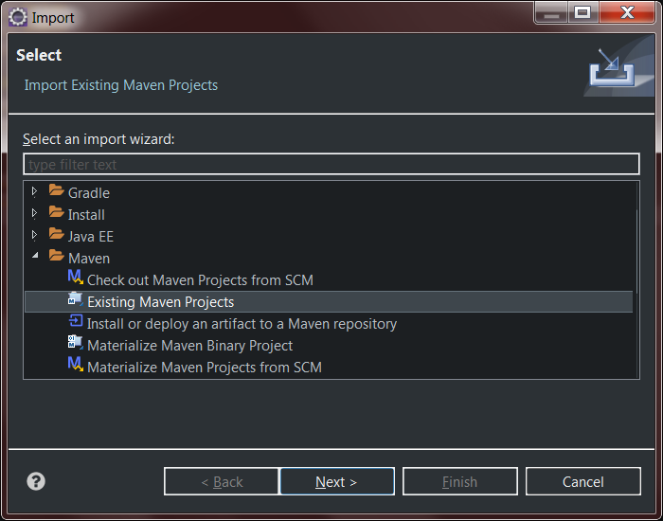
4. Click Next  
   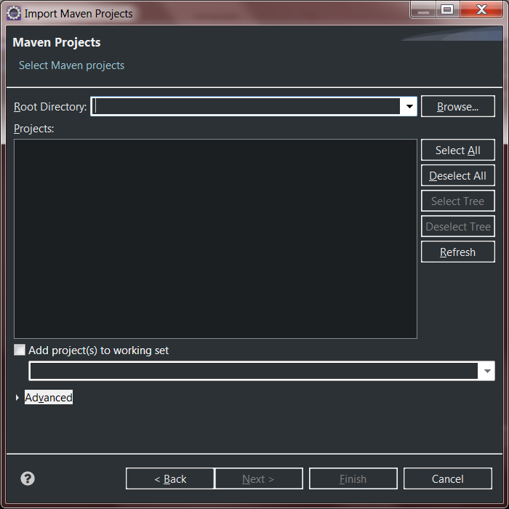
5. Click brose and select the folder you unzipped from the Spring initializer site. 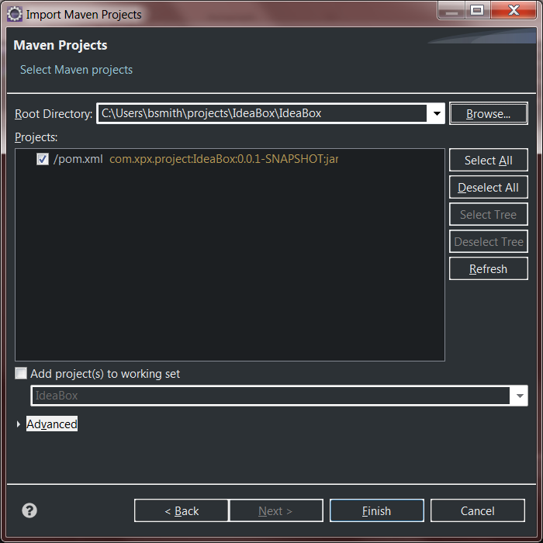
6. Click Finish

At this point your project will be getting imported into eclipse and should be ready to go.